2023 Application

Weekly Camping Program
Camp Discovery, a camping facility designed to serve people with intellectual and developmental disabilities, is owned and operated by the Tennessee Jaycee Foundation, Inc. With cooperation of the students and faculty of Tennessee’s colleges and universities, the programs are designed and implemented especially for our clients. All programing will be in direct consultation with, and closely supervised, by our Camp Director. Our staff will include a core group of admin, teachers, nurses, lifeguards and college students in special education and related fields. Our staff changes somewhat from year to year as we continually work to keep the best and bring in new people who are eager and motivated to serve people with special needs. The camp’s facilities, programming and supervision are all designed to ensure each camper receives a safe and rewarding weeklong experience. The counselor-camper ratio will be as close to one-to-three as possible.
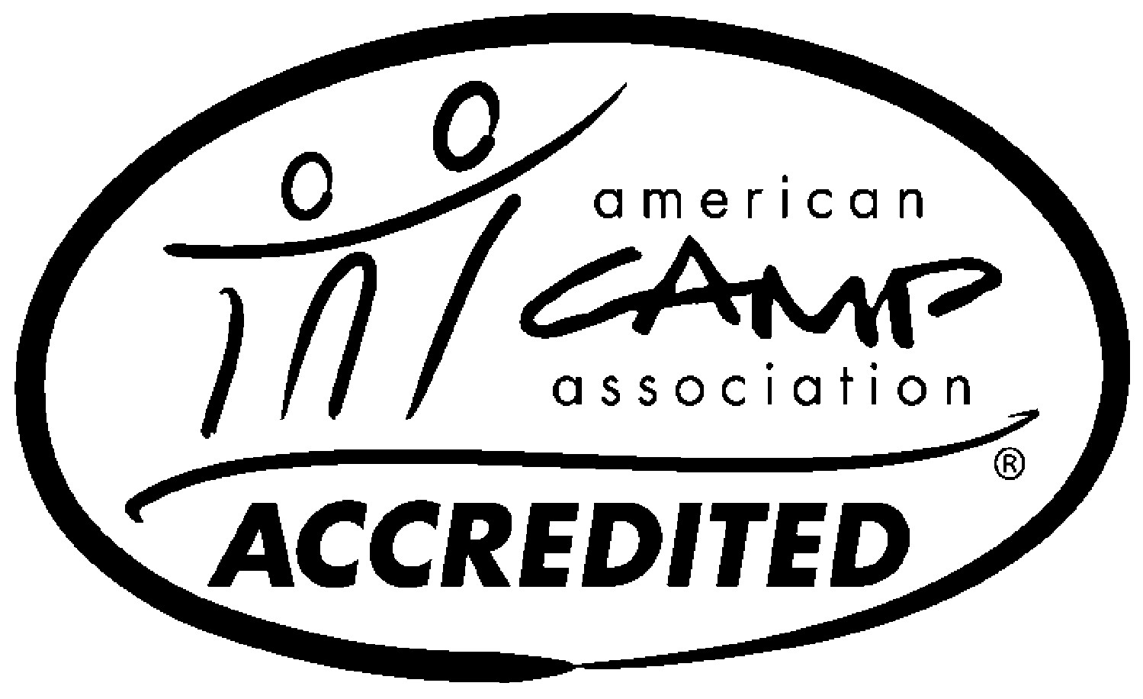

The Program
Activities in the specialty areas will be planned and instructed by experienced staff members. Campers will participate in such activities as: arts and crafts, outdoor recreation, music, games, contests, sports, dancing, movies, cabin activities, and swimming when weather permits. All
activities will be planned to accommodate changes in weather conditions and CDC guidelines for Covid-19.

Primary Objectives
To provide a fun and safe environment during the summer months, using water related and outdoor activities for campers with various special needs. An associated purpose is to provide training for supervisory and administrative personnel who will implement similar camp programs in other states.

Location
The campsite is in the Flynn’s Lick Creek area of Cordell Hull Lake in Jackson County, Tennessee (Gainesboro.) This is approximately halfway between Nashville and Knoxville, about 20 miles north of Interstate 40. The land is flat to rolling with wet weather streams and waterfalls. Approximately 50% of the tract is covered with thick growths of large hardwood trees. The area is conducive to all types of camping activities, i.e., hiking, nature studies, and water activities.

Dormitory and Indoor Activities All dormitories are fully insulated, heated, and air- conditioned to be comfortable. The Camp also has a large heated and air-conditioned Dinning Hall/Recreational Area and other buildings to accommodate all activates during inclement weather.

Arrival and Departure
Campers should report to camp between 2:00 pm and 4:00 pm, central time-CST, on Sunday of the scheduled week. Report to the dining hall upon arrival. ALL medications/vitamins must be left with the Nurse at this time. Campers will need to be picked up the following Friday between 9:00 am and 11 am, central time, CST.
-NO reservation will be accepted by telephone. - Reservations will be made only after the completed application (including week choices, medical information, and paid registration fees) has been received in our office. - You will receive an electronic confirmation number within ten days of receipt of your completed application. Groups with one confirmation number may not switch campers from other weeks.

Camper Fee
The cost per camper is $575.00 (as of January 25, 2023.) This includes all supervision, teaching, craft supplies, entertainment, food, use of equipment, room, and board (however, please note that we will not be responsible for transportation), and processing fees. If a camper needs to change their arrival date, it must be done at least two weeks in advance. Cancellations made less than SEVEN days prior to arrival will NOT receive a refund. All fees must be paid in full at least One Week prior to arrival. We will not accept payments on site at camp.
Medical
All medications must be brought to camp in the current prescription bottles and administered by the pharmacist. Two full time nurses are available to dispense medications and provide first aid. Campers on medication and vitamins should bring a seven (7) day supply and a written instruction sheet (see Medical Summary Form) on dosages and times to be dispensed (bottle labels will not be sufficient.) Copies of Medical Administration Record (MAR), Medicaid, Medicare cards, or other insurance information must accompany the camper application. (see Medical Summary Form.) Regretfully, we are unable to accept campers who require tube-feeding, one-on-one assistance, catheter, colostomy, and ileostomy. Refer any questions to the Camp Director.
Food Service
Dinner will be provided on Sunday evening after check-in. During the week, three meals a day will be provided. On Friday, breakfast will be provided prior to departure.

What to Bring
Campers should bring at least the items listed below. The basic rule is to send what your camper would normally wear for one week during the summer months. Make sure the camper has some cool clothing (shorts, t shirts, etc.) since many of the activities are outdoors. All items need to be labeled with camper’s name or initials. Please provide the counselor with a list of the camper’s belongings. Please do not send expensive clothing and items to camp, especially electronic devices, and phones. Camp Discovery will not be responsible for these items if misplaced or stolen.
- 1 set of twin sheets/1 pillow and case
- 2 warm blankets or 1 sleeping bag (bunks and mattress provided only. You must supply linens and blankets.)
- 2 towels and washcloths
- brush/comb/toothpaste/toothbrush
- medications/vitamins, 7-day supply
- personal hygiene articles (shampoo, soap, etc.)
- clothing for 6 days (shorts, jeans, t-shirts, etc.)
- 6 pairs of socks
- 6 pairs of underwear
- 2-3 pairs of shoes (sneakers, sandals, etc.)
- 2 pairs of pajamas
- 1 bathing suit
- a bottle of sunscreen
- 1 raincoat or poncho

DIRECT RESERVATION INQUIRIES:
Chester Lowe, Vice President
2072 Catalina Way Nolensville, TN. 37135 Phone: 615-504-1727 vicepresident@jayceecamp.org

Application for Reservation at Camp Discovery

Name of Camper Applicant | T-shirt size:
Address of Applicant
City | State Zip
Female Male | Date of Birth (accepted ages 7-80)
Phone number (h) | (c)
Name of Non-Emergency Contact | E-Mail

***Please attach a recent photograph of camper***
____________________________________________________ Name of person to contact in the event of an emergency
Name ___________________________________ Relationship to Camper_____________________
Address _________________________________________________________________________
Phone (day)_______________________________(night) __________________________________
E-Mail Address for Confirmation notice__________________________________________________

Dear Parent or Guardian,
As per this application, you have indicated your interest and intention to send us a Camper. The Camper will be under our care and supervision for six days and we need your help to insure his or her safety and enjoyment at Camp
Discovery. We ask that you complete this application and attach any additional information you feel we should know about the Camper. You know them best and know the best approaches to various situations. The more specific information you provide, the better the care we can give the individual Camper.
PLEASE DO NOT LEAVE ANY BLANKS
BE AS SPECIFIC AS POSSIBLE
Please rank the following weeks 1st, 2nd, 3rd, according to your Camper’s more desired weeks. (If your Camper will be attending multiple weeks, rank the multiple weeks with the same ranking.) Weeks are available on first come, first serve bases; we will try to accommodate requested weeks, but if we can’t, we will be filling up each week from the earliest to the latest.
The camp sessions will be on a “First
Come, First Served Basis.” You may call Chester Lowe at 615-504-1727 or email at vicepresident@jayceecamp.org for reservation inquires.
___Week 1: June 11 - 16
___Week 2: June 25-30
___Week 3: July 2-7
___Week 4: July 9-14 (Junior Week)
___Week 5: July 16-21
___Week 6: July 23-28

Camper fee is $575.00 per week. Applications and camper fee must be received by May 15th to ensure the requested week. Applications will still be accepted, but your requested week may have to change. Please indicate below how you will pay the camper fee.
_____Check attached for the amount
of $________
_____Website payment – https://www.campdiscoverytn.org to Tennessee Foundation, Inc.

Make all checks payable to:
Tennessee Jaycee Foundation, Inc
($575.00 per camper, per week)

Mail Application(s) and Check to:
Tennessee Jaycee Foundation, Inc.
2072 Catalina Way,
Nolensville, TN 37135

Name
Sex Height | Weight Age Date of Birth
Address | City State Zip
Phone Number | Marital Status: Single Married
Number of Dependents | Number of Siblings
Name of Father | Occupation
Address | City State | Zip
Name of Mother | Occupation
Address | City State | Zip
Name of Guardian
Address | City State | Zip
Has Applicant been to Camp Discovery before? _______
#of times? ______________ Last time? _______________
If this is your first time, how did you hear about camp?

IMPORTANT THIS FORM MUST BE SIGNED BY THE PARENT/LEGAL GUARDIAN

Date: ______________

I give consent for ______________________________(name of applicant) to attend Camp Discovery .

In consideration for the acceptance of the applicant, we hereby release any claim or cause of action which may occur against CAMP DISCOVERY, the Tennessee Jaycee Foundation, Inc, and the Tennessee Jaycees and any employee of either one and any other person acting with the permission of either, arising out of any injury to his/her person of property during his/her stay at the Camp, in transit to and from said Camp, or during any activity approved by any said persons, and we agree to assume any claim which said child in his/her personal capacity might have against any of said persons for injury as herein stated.

As a contribution to the fight for people with disabilities and for good and valuable consideration, permission is hereby granted to the Tennessee Jaycees, Tennessee Jaycee Foundation Inc, or Project Camp Discovery, to use any photograph(s) of (name of Applicant) __________________________for education, publicity, fund raising purposes, and in any of all publications and other types of news and social media limitations or reservations. To opt-out, please communicate your campers wishes with the director upon arrival.

Name of Parent/Legal Guardian:

Address/City/State/Zip:

Phone Numbers: Home ( ) Work ( )

Email address:

X _______________________________ X______________________________
Signature of parent or legal guardian is Mandatory signature of witness is Mandatory

This application had been filled out by: (Pease Print)
Name Title

Address Daytime phone ( )

Name of Camper

History of Disability and Condition of Applicant
What is the medical diagnosis?

(use medical diagnosis- intellectual disability, autism, cerebral palsy, injury, etc.)

Extend and degree of disability?

(Describe fully)

When was the onset of the disability?

(year and cause, if known)

Daily Living Activities
What care will applicant need in relation to: (describe fully) Regretfully, we are unable to accept campers who require tube-feeding and/or constant one-on-one care. Refer any questions regarding whom can/can’t attend to the Camp Director.

Eating
To what extent will applicant need help in feeding?
Difficulty swallowing solids? Liquids? Require a straw? | Any special utensils?
Other comments pertaining to eating? (likes, dislikes, etc.)
Hearing and Speech
Does applicant hear well? If no, does applicant wear a hearing aid?
Can applicant verbally make his/her needs known?

If no, please describe the type of communication used.
Toilet Needs  Does applicant need assistance? | If yes, give complete instructions
Does applicant have a: Catheter: Colostomy: Ileostomy:
Regretfully, we are unable to accept campers who require catheter, colostomy and ileostomy. Refer any questions regarding whom can/can’t attend to the Camp Director.

Walking Please indicate with a Yes or No
Can walk completely on own? Can walk some? Unable to walk?
If assistance is needed, do you need a cane? Crutches? | Walker?
Is Gait affected? Needs support from counselor to walk?
Requires a wheelchair? Providing own chair? | Manual or Electric?
Can propel on own? Required for all transport? | Just long distances?
Comments?

Name of Camper

Dressing/Undressing/Washing/Bathing/Toileting
Does applicant preform these functions themselves? 100%____75%____50%____25%____less____ Please give a list or description of assistance needed:

Activity Limitations
List what applicant should not attempt (If doctor’s orders, include signed statement from same):

Miscellaneous Information
Under what conditions, if any, does your camper exhibit aggressive or violent behavior and how frequently does such behavior occur? The Camp Director reserves the right to send campers home early who exhibit behaviors which could harm staff or other campers including themselves.

Please state any other problems in personal care, which we should know about:

Does applicant have any special interests, hobbies, skills, etc.?

Any additional instructions that will help us make your camper’s week more enjoyable?

Medical Information
Medications/vitamins (all medications must be in current prescription bottles) List all current medications/vitamins and dosages (use additional sheets if necessary) 1.

2.

3.

4.

5.

Family Pharmacist: name/address/phone:

Allergies Does applicant have allergies? _______ If yes, please list
1 | 2
3 | 4
5 6

Medical Summary
No Camper will be accepted with a condition deemed contagious

Note: This form must be filled out and signed by a physician within a 12-month period prior to the first chosen camping session.

Name |  | Birthdate | Sex | Age
Social Security # |  | Type of Insurance
In an Emergency, notify: |  |  |  | (parent/guardian/spouse)
Telephone Numbers: Home ( | ) |  |  | Work ( )
Insurance Co |  | Policy # |  | Contact #

The above names individual has been invited to spend a week at Camp Discovery, a recreation residential camp that serves people with intellectual and developmental disabilities. Please fill in carefully the information requested.

Health History This section to be filled in by: parent/guardian and approved by the physician at the time of examination.
Condition |  | Approximate Date | Condition |  | Approximate Date | Condition |  | Approximate Date
Ear infections |  |  | Hay Fever |  |  | Chicken Pox
Rheumatic Fever |  |  | Ivy Poisoning |  |  | Measles
Heart Trouble |  |  | Insect Stings |  |  | Mumps
Convulsions |  |  | Infectious Hepatitis |  |  | Asthma
Diabetes |  |  | Kidney Trouble |  |  | Poliomyelitis
Bronchitis |  |  | Mononucleosis |  |  | HIV + (AIDS)

If diabetic, does camper require insulin injections? Yes______ No______ Not Diabetic ______
Operations or serious injury within the last year?
Has there been any recent exposure to contagious disease? | When?
What?
Problems with constipation? Bedwetting? | Fainting?
Any specific activities to be encouraged?

SPECIAL CARE: Suggestions from parents/guardians as to bandages, enemas, special utensils, etc

Parent/Guardians Authorization: This health history is correct as far as I know, and the person herein described has permission to engage in all prescribed camp activities, except as noted by me and the examining physician. In the event I cannot be reached in an EMERGENCY, I hereby give permission to the physician selected by the Camp Director to hospitalize, secure proper treatment for, and to order injection, anesthesia or surgery for the camper as names above.

____________________________ ____________ Mail Medical Summary to:
Legal Guardian’s Signature** Date Tennessee Jaycee
(If camper can legally make his or her own decisions, Camper may sign above) Foundation, Inc
CAMP DISCOVERY
**UNSIGNED FORMS WILL NOT BE ACCEPTED** 2072 Catalina Way
Nolensville, TN 37135

Medical Examination
To be completed by a licensed physician. A history and physical (HP) from the patient’s physician can replace this page, if desired.

CODES: |  | S- Satisfactory |  | X-Not Satisfactory | O- Not Examined

Height | Weight | Blood  Pressure | HGB Test | Urinalysis | Blood type
Eyes  Glasses/contacts | Ears Aid | Lungs | Nose | Throat | Teeth
Heart | Abdomen | Hernia | Extremities | Posture (spine)
Allergies (specify):

General Appraisal:

For Females Only
Has this person menstruated? YES NO If yes, is her menstrual history normal? Yes No If not, has she been told about it? YES NO Special Considerations?

Recommendations and Restrictions while at Camp
Special diet:

Medications and Vitamins (To be brought to Camp with Medical Summary form along with written instructions for each medication and vitamin)
Swimming: YES NO Other physical activity limitations:
Seizure or Convulsions YES NO Type: Frequency: |  | Controlled:
Immunizations  Tetanus Toxoid | Date
Tuberculin Test | Date
Polio Vaccine | Date

Covid-19 Vaccine* Date__________________________________________________
*We strongly suggest all campers who can get the vaccine to get it and show proof before arriving to camp. If the camper is unable to receive the vaccine, you will be asked to sign a waiver upon arrival for liability purposes.

Physician: I have examined the person herein described and have reviewed his/her health history. It is my opinion that he/she is physically able to engage in camp activities, except as noted above.
Date Examining Physician’s Signature

Telephone ( ) Address

The camp sessions will be on a
“First Come, First Serve Basis.”

You may call Chester Lowe at 615-504-1727 or email at vicepresident@jayceecamp.org concerning reservations.

All camp fees should be paid in full one week prior to arrival, unless proper financial arrangements have been made. Camping fees for cancellations made less than seven (7) days prior to arrival dates will not be refunded.

The Camp Director will be in contact with applicants 10 to 14 days prior to arrival to health screen for risk of Covid-19 spread.

Directions to Camp Discovery
400 Camp Discovery Lane, Gainesboro, TN 38562

From East Tennessee
- Take I-40W to Baxter/Gainesboro exit #280 (west of Cookeville)
- Turn north onto HWY 56N to Gainesboro and turn left on HWY 53 (just past the Dairy Queen, go through town)
- Go six (6) miles and turn right at the Camp Discovery sign onto White’s Bend Lane (Recreation Area)
- Go two (2) miles and turn left at the Camp Discovery sign (on the left side-just beyond the Darwin Cemetery)
- Proceed, up the hill, approximately one-half (1/2) mile to Camp Discovery.

From West Tennessee
- You may follow the above directions (I-40 E exiting at Baxter/Gainesboro exit #280) -OR-take the following alternate route (winding steep roads at times.)

- Take I-40E to Gordonsville/Carthage Exit (South Carthage) (approximately 50 miles east of Nashville)
- Turn left off exit ramp onto HWY 53N toward Carthage and go approx. five (5) miles to HWY 70.
- Turn right on HWY 70 and go approx. 7.5 miles to the Chestnut Mound community.
- Turn left on HWY 53 toward Gainesboro (this is directly across from the post office.) You’ll pass through the Granville and Flynn’s Lick communities (approximately 13 miles total)
- On your left will be a sign for the White’s Bend Recreation Area, ¼ mile beyond is a Camp
Discovery sign on the right side of the road, turn left at the Camp Discovery sign onto White’s Bend Lane.
- Go two (2) miles and turn left at the Camp Discovery sign (on the left side-just beyond Darwin Cemetery)

